El Camino Hospital (ECH) is a not-for-profit organization with hospital campuses in Mountain View and Los Gatos, California. The hospitals have served communities in the San Francisco Bay Area for nearly 50 years.

ECH has a website that is currently serving the desktop users. In order to better serve the mobile consumers with a many different kinds of platforms such as iPhone or Android, ECH is in need of new version to serve the mobile users. This new version has the following main functions:

* Emergency Response
* Find a Doctor
* My Family & Me
* ECH Resources
* Visiting ECH
* ECH News & Events

The purpose of this project is to develop a HTML5 based web application so that it can function well on both iPhone and Android mobile phones then develop the iPhone and Android hybrid applications to link with the HTML5 web app.

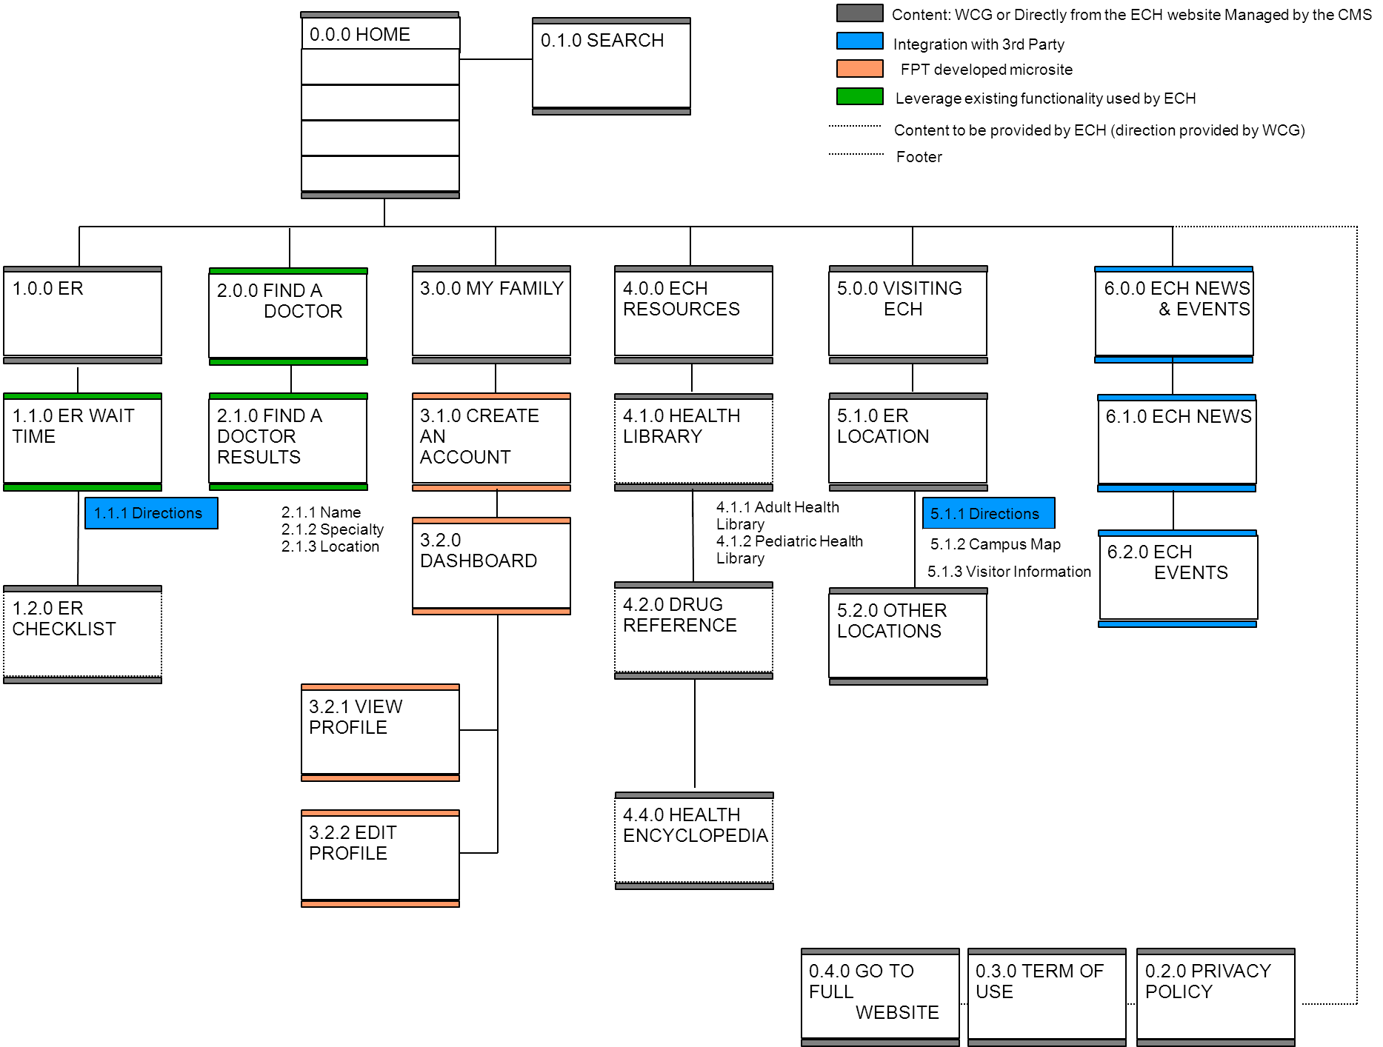



Figure 2 – Homepage

Display the homepage and main application menu

Figure 3 – Search

1. The search results are all pages that contain the matching keyword, except for the ones belong to My Family & Me

2. The initial search result contains no more than 10 records. User can tap View More button to view ten more results



Figure 4 – Screen Flow: Find a Doctor by Name

The initial search result contains no more than 10 records. User can tap View More button to view 10 more results



Figure 5 – Screen Flow: Find a Doctor by Specialty



Figure 6 – Screen Flow: Find a Doctor by Location



Figure 8 – Screen Flow: Emergency Response

Find the way to go to the emergency room

Display the wait time of emergency rooms in two locations of ECH: Mountain View and Los Gatos

Display the information of the emergency room in a location (Mountain View or Los Gatos)

Get the information of the preparation checklists for emergency room



Figure 10 – ER Checklists



Figure 11 – Screen Flow: Visiting ECH

Display the general information of hospital in the Hospital Profile page

View Campus Map

Display the information of other locations of ECH besides Mountain View and Los Gatos



Figure 13 – Visitor Information



Figure 14 – Screen Flow: ECH Resources – Health Library

Provide the list of useful information of adult and pediatric health



Figure 15 – Screen Flow: ECH Resources – Drug Reference

Provide the reference of drug types



Figure 16 – Screen Flow: ECH Resources – Health Encyclopedia

Provide a reference for health information



Figure 17 – Screen Flow: ECH News & Events

Provide user the latest news from external sources such as: Youtube, Facebook, Twitter, RSS feed, Links (the articles and podcasts uploaded via the CMS)

Provide user the latest events of ECH

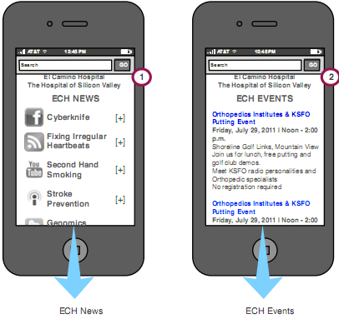

Figure 18 – ECH News & Events



Figure 19 – Screen Flow: Login

Authenticate user before granting access to My Family & Me pages



Figure 20 – Screen Flow: Forgot Password

Allow user to get back the forgotten password



Figure 21 – Screen Flow: Change Password

Allow user to change the password



Figure 22 – Screen Flow: Create Account

Create a login account for My Family & Me



Figure 23 – Screen Flow: Delete Account

Delete user’s account from FMO system and its family profile records



Figure 24 – Screen Flow: Dashboard



Figure 25 – Screen Flow: Add Profile

A member profile is added to database



Figure 26 – Screen Flow: View Profile



Figure 27 – Screen Flow: Edit Profile



Figure 28 – Screen Flow: Delete Profile

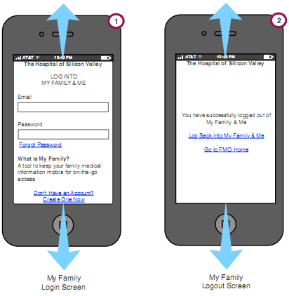

Figure 29 – Login & Logout